Tuesday, March 24th 2015

Greetings CPCS Community !

How glad I am when I have seen
Those tender leaves of gentle green.
They warm my heart and make it sing
For now I know at last it's spring!
-Author Unknown-

Please keep in mind the below important dates and reminders!

Friendly reminders/Important information and dates:

- Parent Workshop: Test Success 101 (3rd and 4th Grade Focus) – Wednesday, March 25th , 5:30-6:30 PM in Room 303
- Senior Academy Showcase – Saturday, March 28th
- Spring Recess – School Closed Friday, April 3rd through April 10th (Students Return Monday, April 13th)
- Community Partnership Charter School Applications Grades Pre-K through 8th for the 2015-16 School Year are now available. Paper applications can be picked up in the Main Office and online applications can be completed at https://app.jumpro.pe/charterapply#school=50 . The Deadline for online applications is Wednesday, April 8th at 5 PM.
- With the cooperation of the weather we will be conducting daily outdoor dismissals. For inclement weather days dismissal will be conducted in the auditorium.

Spring Has Sprung at CPCS Lower School

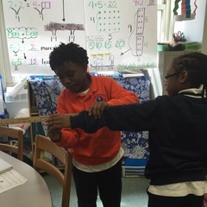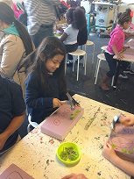

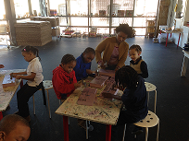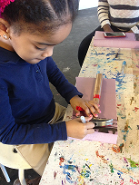

Parent Workshop:
Test Success 101

Wednesday, March 25th
5:30 - 6:30 pm
Room 303

Join us and learn some SIMPLE TIPS for student success!

****Free giveaways for your attendance and participation!!!****

